**Tables, Graphs & Interpretations**

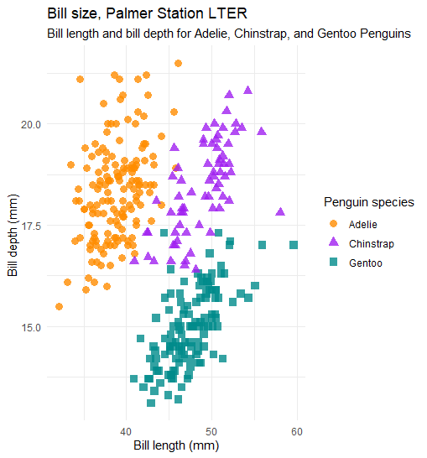

Interpretations of Scatter Plot: Variables bill depth (mm) and bill length (mm) were assessed. Gentoo penguins had the shortest bill depth. Adelie penguins had the shortest bill length. Chinstrap penguins possessed similar bill length to Gentoo and similar bill depth to Adelie.

#Variable Class

class(penguins$sex)

class(penguins$body_mass_g)

class(penguins$species)

class(penguins$island)

class(penguins$bill_length_mm)

class(penguins$bill_depth_mm)

class(penguins$flipper_length_mm)

| **Variable Name** | **Class** |
| --- | --- |
| Sex | Factor |
| Body_mass_g | Integer |
| Species | Factor |
| Island | Factor |
| Bill_length_mm | Numeric |
| Bill_depth_mm | Numeric |
| Flipper_length_mm | Integer |

#Variable Levels

levels(penguins$sex)

levels(penguins$body_mass_g)

levels(penguins$species)

levels(penguins$island)

levels(penguins$bill_length_mm)

levels(penguins$bill_depth_mm)

levels(penguins$flipper_length_mm)

| Variable Name | Levels |
| --- | --- |
| Sex | "female";"male" |
| Body_mass_g | Null |
| Species | "Adelie","Chinstrap","Gentoo" |
| Island | "Biscoe","Dream","Torgersen" |
| Bill_length_mm | Null |
| Bill_depth_mm | Null |
| Flipper_length_mm | Null |

#Missing Data

is.na(penguins)

#Analysis with NA value

penguins %>%

group_by(island) %>%

summarise(mean(bill_length_mm))

#Summarise

summary(penguins)

# Bar graph counts > colorblind palettes

penguins %>%

count(species) %>%

ggplot() + geom_col(aes(x = species, y = n, fill = species)) + geom_label(aes(x = species, y = n, label = n))+scale_fill_manual(values = c("deepskyblue","blue","green")) + theme_minimal() + labs(title = 'Species Population')

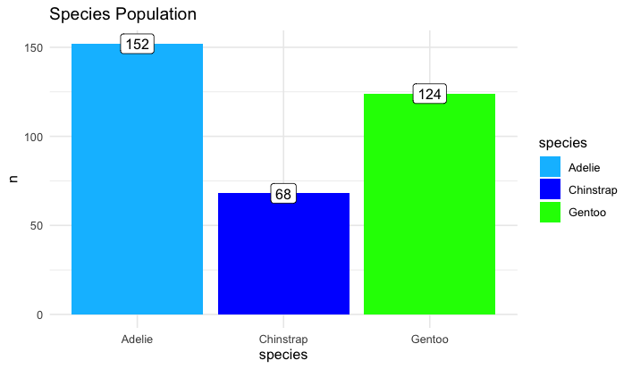

Interpretations of Bar Graph: Number of penguins per species. Adelie: 152; Chinstrap: 68; Gentoo: 124

#Summarize

summary(penguins$species)

summary(penguins$island)

summary(penguins$sex)

summary(penguins)

| Variable | Summary |
| --- | --- |
| Species | Adelie: 152; Chinstrap: 68; Gentoo: 124 |
| Island | Biscoe: 168; Dream: 124; Torgersen: 52 |
| Sex | Female: 165; Male: 168; NA's:11 |

| Summary Statistics | Flipper_length_mm | Body_mass_g | Bill_length_mm | Bill_depth_mm |
| --- | --- | --- | --- | --- |
| Minimum | 172 | 2700 | 32.1 | 13.1 |
| 1st Quartile | 190 | 3550 | 39.23 | 15.6 |
| Median | 197 | 4050 | 44.45 | 17.3 |
| Mean | 200.9 | 4202 | 43.92 | 17.15 |
| 3rd Quartile | 213 | 4750 | 48.5 | 18.7 |
| Maximum | 231 | 6300 | 59.6 | 21.5 |
| NA's | 2 | 2 | 2 | 2 |

**Code For Assignment 3 & Group Research Question**

**How does flipper mass density vary by penguin species?**

# Subset

mod_adelie <- lm(penguins$body_mass_g[penguins$species == "Adelie"] ~ penguins$flipper_length_mm[penguins$species == "Adelie"])

summary(mod_adelie)

mod_adelie$coef

plot(penguins$flipper_length_mm[penguins$species == "Adelie"],penguins$body_mass_g[penguins$species == "Adelie"],main = "Scatterplot")

abline(mod_adelie)

mod_chinstrap <- lm(penguins$body_mass_g[penguins$species == "Chinstrap"] ~ penguins$flipper_length_mm[penguins$species == "Chinstrap"])

summary(mod_chinstrap)

mod_chinstrap$coef

plot(penguins$flipper_length_mm[penguins$species == "Chinstrap"],penguins$body_mass_g[penguins$species == "Chinstrap"],main = "Scatterplot")

abline(mod_chinstrap)

mod_gentoo <- lm(penguins$body_mass_g[penguins$species == "Gentoo"] ~ penguins$flipper_length_mm[penguins$species == "Gentoo"])

summary(mod_gentoo)

mod_gentoo$coef

plot(penguins$flipper_length_mm[penguins$species == "Gentoo"],penguins$body_mass_g[penguins$species == "Gentoo"],main = "Scatterplot")

abline(mod_gentoo)

**Individual Research Questions:**

Giovanni: Does flipper density vary by island of origin?

Nani : Does Body mass depend vary among species variety?